
REAL-TIME HEURISTIC-BASED DDoS DETECTION SYSTEM
USING PACKET-LEVEL TRAFFIC ANALYSIS

Team Members: Anushree Balaji, Arman Deshmukh
University: NMIMS MPSTME
Academic Year: 2026-27

Under the mentorship of

Prof. Dipali Maste

Acknowledgement
The completion of this project report reflects the combined influence of academic supervision, peer discussion, and disciplined technical experimentation. The author gratefully acknowledges the guidance of the project supervisor, the support of the department, and the availability of high-quality open technical tooling used throughout the implementation and evaluation process.
Special appreciation is extended to the maintainers of the Python networking and data analysis ecosystem, whose libraries enabled rapid prototyping, transparent experimentation, and reproducible analysis. The debugging effort surrounding dataset truncation and heuristic calibration also benefited from careful documentation practices, which transformed evaluation difficulties into a valuable engineering contribution rather than a project setback.

Abstract
Distributed Denial of Service attacks remain one of the most disruptive categories of network abuse because they can exhaust bandwidth, server resources, and service availability within seconds. This report documents the design, implementation, and evaluation of a real-time heuristic-based DDoS detection system that operates on packet-level network traffic aggregated into one-second windows. Instead of relying solely on statistical learning, the implemented system prioritizes deterministic feature extraction, weighted rule scoring, attack probability estimation, and interpretable classification logic.
The implemented pipeline centres on raw network traffic analysis, feature engineering, a six-rule heuristic decision engine, and a diagnostic visualization workflow. The extracted features include packet rate, byte rate, protocol-specific rates, SYN/ACK asymmetry, packet size variance, unique source and destination cardinalities, entropy metrics, and timing characteristics. Each one-second feature window is scored using a weighted heuristic model and then mapped through a sigmoid function to produce an attack probability and a final attack label.
A significant contribution of the project is the dataset audit performed during evaluation. The provided CIC-DDoS2019 subset produced unexpectedly low recall because the source captures were shown to be severely truncated and therefore non-representative of genuine volumetric floods. Synthetic flood validation demonstrated that the heuristic engine remains structurally sound and correctly detects high-rate attack traffic when presented with realistic volumetric conditions. The report therefore describes not only the implemented detection architecture, but also the engineering reasoning used to separate algorithm limitations from dataset limitations.

Table of Contents
Acknowledgement
Abstract
1. Introduction
1.1 Background of DDoS Attacks
1.2 Motivation
1.3 Problem Statement
1.4 Objectives
1.5 Scope of the Work
1.6 Contributions of the Project
2. System Design
3.1 Architectural Overview
3.2 Workflow and Module Interaction
3.3 Data Flow and Intermediate Representation
3.4 Design Interpretation: Implemented Core Versus Broader Vision
3. Dataset
4.1 Dataset Context
4.2 PCAP File Structure and Why It Matters
4.3 One-Second Window Generation
4.4 Preprocessing and Metadata Awareness

Chapter 4 - Feature Engineering
5.1 Feature Engineering Philosophy
5.2 Volume and Rate Features
5.3 Packet Size Features
5.4 TCP Flag and Protocol Features
5.5 IP Distribution and Entropy Features
5.6 Timing Features
5.7 Feature Vector Integration
4. Heuristic Decision Engine

Chapter 5 - Heuristic Decision Engine
6.1 Core Scoring Mechanism
6.2 Severity Scaling
6.3 Probability Mapping by Sigmoid Function
6.4 Attack Classification Logic
6.5 Calibration Perspective
5. Implementation

Chapter 6 - Implementation
7.1 Repository Structure
7.2 Main Orchestration Layer
7.3 Feature Engineering Submodule
7.4 Decision Engine Submodule
7.5 Configuration, Reports, and Utility Support
6. Experimental Results

Chapter 7 - Experimental Results
8.1 Evaluation Philosophy
8.2 Heuristic Score Distribution
8.3 Confusion Matrix Interpretation
8.4 Performance Metrics and What They Mean
8.5 Probability Curve and Decision Regions
7. Dataset Analysis and Limitations

Chapter 8 - Dataset Analysis and Limitations
9.1 Why This Chapter Matters
9.2 Overlapping Feature Distributions
9.3 PCAP Metadata Root Cause
9.4 Proof of Engine Viability Through Synthetic Validation
9.5 Algorithm Limitations Versus Dataset Limitations
9.6 Chapter Conclusion
8. Future Work

Chapter 9 - Future Work
10.1 Engineering Extensions
10.2 Research Extensions
9. Conclusion

Chapter 10 - Conclusion
11.1 Summary of Achievements
11.2 Lessons Learned
11.3 Architecture Quality and Extensibility
References

List of Figures
Figure 1: High-level context diagram summarising the implemented heuristic detection workflow.
Figure 2: Overall architecture of the implemented heuristic DDoS detection pipeline.
Figure 3: Representative intermediate packet record schema used before one-second aggregation.
Figure 4: One-second window generation process used by the implemented feature pipeline.
Figure 5: Pseudocode summary of the heuristic scoring and attack-identification process.
Figure 6: Repository structure reconstructed from the attached walkthrough and prompt requirements.
Figure 7: Placeholder for heuristic score distribution output produced by the visualization module.
Figure 8: Placeholder for confusion matrix generated by the project visualization scripts.
Figure 9: Placeholder for probability curve derived from the heuristic score-to-probability mapping.
Figure 10: Metadata-based proof that the supplied SYN flood trace is severely sparse.

List of Tables
Table 1: Project objectives and how each objective is evidenced by the attached implementation documents.
Table 2: Comparative view of major DDoS detection paradigms in relation to the implemented project.
Table 3: Interaction of the principal modules documented in the repository walkthrough and technical notes.
Table 4: Dataset selection and exclusion logic derived from the registry-triage documentation.
Table 5: Essential PCAP global-header fields relevant to packet-level analysis.
Table 6: Interpretation of the principal engineered features used by the detection pipeline.
Table 7: Weighted rule system used by the heuristic scorer.
Table 8: Implementation interpretation of the repository structure and each area's role.
Table 9: Contrast between benchmark evaluation and synthetic validation of the heuristic engine.

Chapter 1 - Introduction

1.1 Background of DDoS Attacks
Distributed Denial of Service attacks aim to make a service unavailable by overwhelming the victim with traffic volume, protocol abuse, or state exhaustion. In operational environments this may manifest as saturated uplinks, exhausted connection tables, degraded application responsiveness, or complete outage. Because attack traffic can arrive from many geographically distributed sources, purely manual response is rarely fast enough to preserve availability once the attack has gathered momentum.
The attached project documentation consistently frames DDoS defence as a packet-centric problem [1]-[7]. The core challenge is not merely recognising that traffic is high, but determining whether the observed traffic pattern violates the expected structural behaviour of normal network operation. For this reason, the system described in this report analyses raw packet attributes, aggregates them into one-second behavioural windows, and evaluates those windows using deterministic logic that can be inspected and tuned.
Although an early project planning document discussed hybrid thresholding, machine learning, dashboards, and firewall orchestration [7], the implemented repository evolved toward a more rigorous heuristic architecture. The final documented implementation emphasises packet parsing, sliding-window feature extraction, weighted rule scoring, attack-type identification, and diagnostic evaluation. This report therefore focuses on the implemented heuristic-based pipeline rather than on broad conceptual modules that were only part of the initial planning stage.

1.2 Motivation
The motivation for the project is twofold. First, DDoS attacks remain operationally relevant because even modest floods can interrupt web services, internal applications, and shared infrastructure. Second, the opacity of many black-box detection models makes them difficult to justify in academic and operational settings where explainability matters. A heuristic detector provides a transparent alternative: every alert can be traced to a concrete set of breached conditions.
The repository walkthrough and decision-engine documentation show that explainability was not an afterthought but a design principle [3], [6]. The scorer records which rules contributed to the heuristic score, the classifier derives the attack label from the decision trace, and the visualization layer produces interpretable plots rather than only aggregate statistics. This combination makes the system suitable for a final-year cybersecurity project because it demonstrates both engineering practice and analytic accountability.

1.3 Problem Statement
The problem addressed by this project is the reliable identification of volumetric and protocol-oriented DDoS anomalies from packet-level network observations in near real time. A practical detector must convert raw traffic into compact behavioural features, infer whether those features represent benign or malicious activity, and do so without excessive latency.
The system must also remain robust when the underlying dataset is imperfect. The attached dataset analysis later shows that benchmark artefacts can distort evaluation results when they no longer preserve true flood characteristics [4]. Therefore, the engineering problem is broader than classification alone; it includes feature design, threshold calibration, interpretability, and forensic validation of the underlying data source.

1.4 Objectives
- To process packet-level network traffic into one-second behavioural windows suitable for rapid decision-making.
- To engineer features that capture volumetric, protocol, distributional, and timing characteristics of network activity.
- To implement a deterministic heuristic decision engine that produces both a weighted score and an interpretable attack probability.
- To classify the dominant attack type from the rule activation trace rather than returning only a binary attack label.
- To evaluate the detector using visual diagnostics, confusion analysis, and metric interpretation.
- To investigate whether poor evaluation metrics originate from the algorithm or from the benchmark dataset itself.
Objective | Implementation Evidence
Packet-level visibility | Feature extraction and entropy modules aggregate raw traffic into fixed windows [2], [6].
Interpretability | Weighted rules and decision trace exposed by scorer and classifier modules [3].
Near-real-time operation | One-second windowing used throughout the documented feature pipeline [2].
Evaluability | Visualization scripts generate score distributions, confusion matrices, and metrics [5], [6].
Engineering validation | Dataset audit separates heuristic weakness from dataset truncation [4].
Table 1: Project objectives and how each objective is evidenced by the attached implementation documents.

1.5 Scope of the Work
The present implementation scope covers packet-level feature extraction, entropy-assisted behaviour summarisation, heuristic scoring, attack-type identification, and evaluation artefacts. The repository documentation explicitly identifies `src/feature_engineering/`, `src/decision_engine/`, `src/visualization/`, `configs/`, `datasets/`, and `main.py` as the core project assets [6]. This makes the implemented core academically substantial even without claiming a fully productionised end-to-end mitigation stack.
Accordingly, this report treats live firewall automation, distributed deployment, dashboards, and adaptive online learning as future extensions unless the attached documents describe them as design intent rather than as validated repository modules. This distinction is important because the user explicitly requested that the report describe the implemented heuristic system and avoid inventing modules that do not exist.

1.6 Contributions of the Project
- A packet-level, one-second sliding-window feature engineering workflow for DDoS detection.
- A six-rule weighted heuristic scorer normalised to a 100-point decision scale.
- A sigmoid-based attack probability mapping that creates meaningful suspicious and attack boundaries.
- Attack-type differentiation using the rule activation trace rather than post-hoc speculation.
- A diagnostic visualization layer for score distributions, confusion matrices, and metric interpretation.
- A detailed audit proving that the extremely low recall observed on the supplied subset was caused by dataset truncation rather than by structural weakness in the heuristic engine.
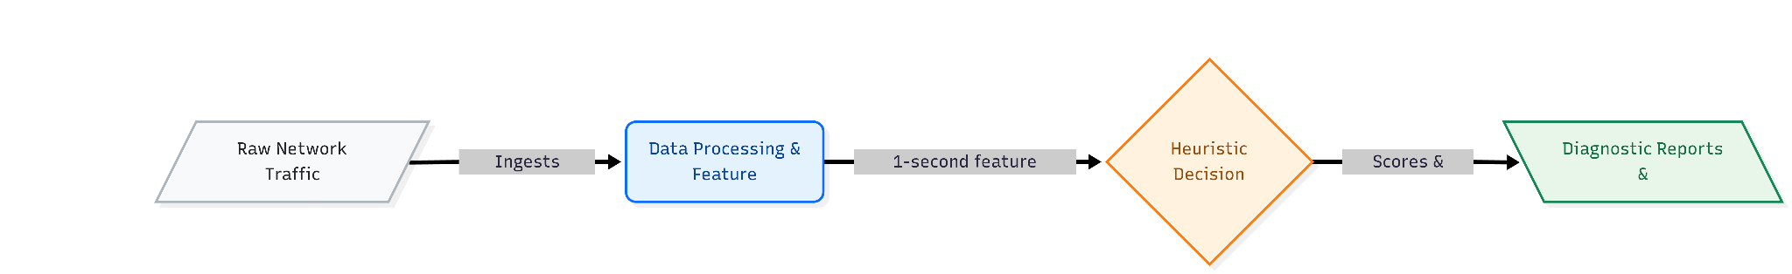
Figure 1: High-level context diagram summarising the implemented heuristic detection workflow.

Chapter 2 - System Design

3.1 Architectural Overview
The implemented architecture is organised as a modular packet-analysis pipeline. Raw packet captures or live traffic feeds are parsed into packet records, aggregated into one-second windows, transformed into a feature vector, scored by the heuristic engine, classified by attack type, and finally analysed through a visualization layer [1], [2], [3], [5], [6]. The architecture is intentionally decomposed so that each stage has a narrow and defensible responsibility.
This modularity serves three purposes. First, it reduces coupling between parsing and decision logic. Second, it makes calibration possible without rewriting feature extraction code. Third, it supports transparent evaluation, because the features, scores, and visual outputs are all inspectable independently. In educational cybersecurity projects, this separation is critical because it demonstrates engineering discipline rather than a monolithic script that hides failure modes.
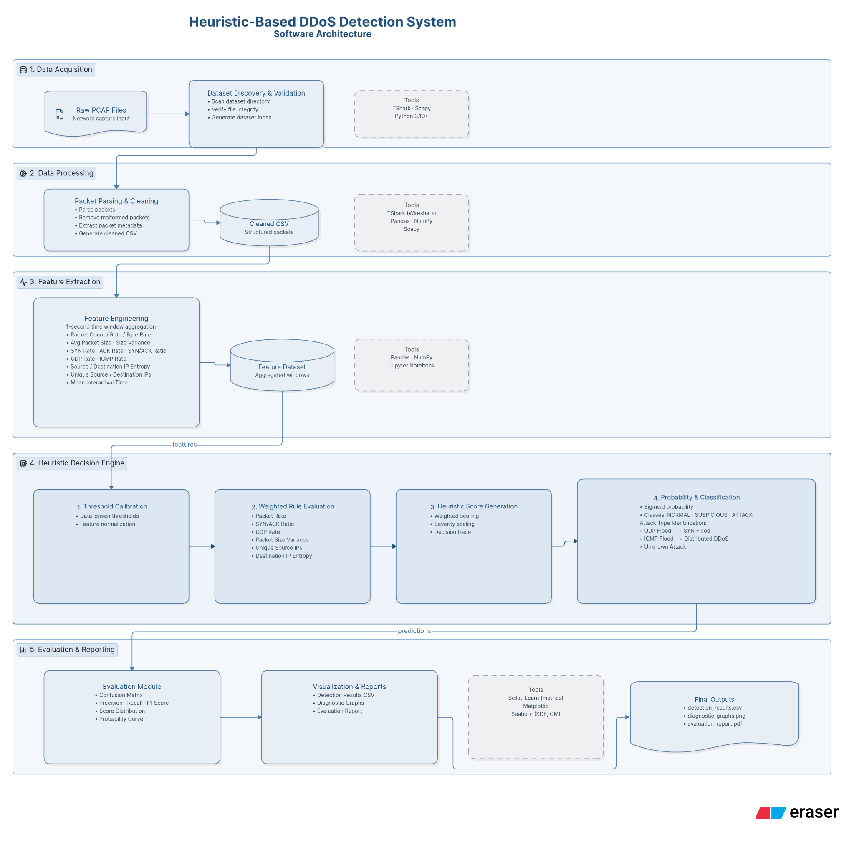
Figure 2: Overall architecture of the implemented heuristic DDoS detection pipeline.

3.2 Workflow and Module Interaction
The workflow begins with packet ingestion. According to the architecture notes, the parser extracts header-level metadata across Ethernet, IP, TCP, UDP, and ICMP where appropriate [1], [2]. This intermediate representation is then passed to the feature-engineering stage, which computes both raw rate statistics and higher-order distributional indicators such as entropy and interarrival behaviour.
The output of feature extraction is a compact per-window vector, which is fed into the decision engine. The scorer calculates a heuristic score, the probability mapper converts that score into an attack likelihood, and the classifier/attack identifier interprets the rule activation pattern to name the most plausible attack class [3], [6]. Diagnostic scripts then render the behaviour of the detector into KDE distributions, confusion matrices, and metric summaries [5].
Module | Primary Responsibility | Documented Evidence
Packet parser / extractor | Collect packet-level fields and build one-second windows | Architecture and feature notes [1], [2].
Entropy helper | Compute source/destination distribution randomness | Feature engineering and repository walkthrough [2], [6].
Scorer | Apply six weighted rules and produce heuristic score | Decision engine note [3].
Classifier / attack identifier | Map decision trace to attack category | Repository walkthrough [6].
Visualization | Generate KDE, confusion matrix, and metrics | Output and evaluation note [5].
Table 3: Interaction of the principal modules documented in the repository walkthrough and technical notes.

3.3 Data Flow and Intermediate Representation
The architecture documentation provides a useful intermediate table abstraction in which every packet contributes fields such as timestamp, source IP, destination IP, protocol, size, SYN status, ACK status, UDP status, and ICMP status [1]. This representation is deliberately narrow: it preserves the behavioural facts needed by the heuristic rules while avoiding unnecessary payload dependence.
Such a design improves reproducibility. If the same packet stream is replayed, the same intermediate table and therefore the same feature windows should be obtained, assuming the windowing parameters remain fixed. This predictability is essential for debugging because it allows the investigator to determine whether a failure originated in parsing, feature computation, threshold calibration, or dataset fidelity.
Illustrative Intermediate Packet Record Schema
Timestamp | Src IP | Dst IP | Proto | Size | SYN | ACK | UDP | ICMP
-------------------------------------------------------------------
10:01:01.002 | 1.1.1.1 | 192.168.1.5 | TCP | 60 | 1 | 0 | 0 | 0
10:01:01.045 | 2.2.2.2 | 192.168.1.5 | UDP | 512 | 0 | 0 | 1 | 0
10:01:01.090 | 3.3.3.3 | 192.168.1.5 | ICMP| 74 | 0 | 0 | 0 | 1
Figure 3: Representative intermediate packet record schema used before one-second aggregation.

3.4 Design Interpretation: Implemented Core Versus Broader Vision
Several attached materials describe a broader defensive vision that includes progressive mitigation stages, firewall integration, and live dashboarding [1], [7]. These documents remain valuable because they explain the intended operational context of the detector. However, the clearest evidence of the implemented repository lies in the feature-engineering, decision-engine, and visualization modules [2], [3], [5], [6].
This report therefore takes a conservative and academically honest stance. It presents the packet-analysis and heuristic-scoring workflow as the validated implementation core, while describing mitigation escalation and extended orchestration as architectural direction. Such discipline protects the report from over-claiming and aligns with the user instruction not to invent modules that do not exist.

Chapter 3 - Dataset

4.1 Dataset Context
The project documentation presents two complementary dataset perspectives. The first is the practical evaluation perspective, where a supplied CIC-DDoS2019 subset is used as the immediate benchmark for feature extraction and heuristic assessment [4], [7]. The second is the registry-triage perspective, where raw PCAP-oriented corpora such as Bot-IoT, Malware Traffic Analysis, Network Packet Dumps, and IoT-23 are identified as strategically useful because they contain packet-level evidence better aligned with heuristic analysis [1].
This dual perspective matters. A heuristic detector requires raw or near-raw packet structure, not just high-level application logs. The retained datasets in the triage note are valuable precisely because they preserve Ethernet/IP traffic from which direct behavioural rules can be constructed. Conversely, wireless-specific datasets and post-execution system logs were excluded because they do not match the detector's network-layer focus [1].
Dataset or Source | Status | Reason for Inclusion or Exclusion
CIC-DDoS2019 subset | Used in evaluation | Immediate benchmark available to the project; later shown to be truncated for volumetric analysis [4].
Bot-IoT | Retained in triage | Contains raw volumetric attack profiles suitable for threshold reasoning [1].
Malware Traffic Analysis | Retained in triage | Useful for authentic anomalous communication baselines [1].
Network Packet Dumps | Retained in triage | Provides raw benign traffic for normal-baseline estimation [1].
IoT-23 raw PCAP subsets | Partially retained | Supports benign and malware traffic profiling in packet form [1].
Wireless-specific and application-log datasets | Excluded | Misaligned with Layer 3/4 packet-centric heuristic objectives [1].
Table 4: Dataset selection and exclusion logic derived from the registry-triage documentation.

4.2 PCAP File Structure and Why It Matters
The rule-based architecture note gives a concise but technically important summary of PCAP structure [1]. A PCAP file comprises a global header followed by repeated per-packet headers and raw packet bytes. For a packet-level DDoS detector this structure is not incidental; it is the substrate from which timing, lengths, protocol identifiers, and transport-state indicators are extracted.
Because the detector reasons over packet rates, protocol proportions, entropy, and interarrival patterns, the integrity of timestamps and packet counts is fundamental. If the capture has been truncated, sparsified, or aggressively filtered, the detector is no longer observing the true volumetric behaviour of the attack. The dataset audit later demonstrates exactly this failure mode for the supplied SYN flood sample [4].
Global Header Field | Purpose
Magic Number | Identifies PCAP format and byte ordering.
Version Major / Minor | Declares the format version used by the capture library.
Timezone / Timestamp Accuracy | Provides timing context for the capture environment.
Snapshot Length | Defines maximum bytes captured per packet.
Link Layer Type | Specifies whether the payload begins with Ethernet or another framing layer.
Table 5: Essential PCAP global-header fields relevant to packet-level analysis.

4.3 One-Second Window Generation
All attached feature notes assume a fixed time window of T = 1.0 second [2]. This design is well chosen for a near-real-time detector. First, it produces rates that are easy to interpret operationally, such as packets per second and bytes per second. Second, it offers sufficiently fine temporal granularity to expose floods quickly without waiting for long aggregation intervals. Third, it creates a natural unit for confusion analysis and visualization because every window becomes a compact observation with a single score, probability, and label.
The one-second choice also supports the low-level debugging performed during the dataset audit. When the supposedly malicious windows average only 14 or even 5 packets per second, the mismatch becomes immediately intelligible to the engineer [4]. Larger windows could have hidden this problem behind smoothing effects. Therefore, one-second aggregation is not only an implementation convenience but also an analytic advantage.
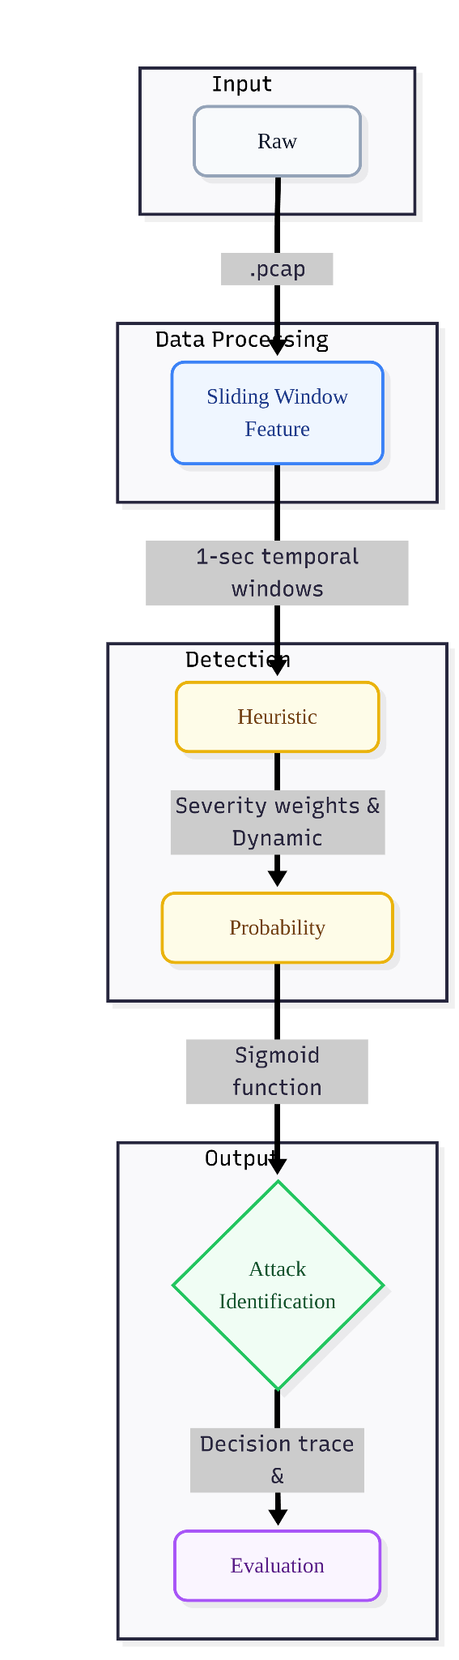
Figure 4: One-second window generation process used by the implemented feature pipeline.

4.4 Preprocessing and Metadata Awareness
Before scoring can occur, packet records must be normalised into a stable intermediate representation. This includes extracting timestamps, lengths, IPs, protocol identifiers, and relevant transport-layer state. The preprocessing objective is not to over-engineer the data, but to preserve the behavioural facts needed by the heuristic engine.
The attached dataset limitation analysis extends this mindset from per-packet parsing to per-capture validation [4]. A PCAP must be evaluated not just as a source of packets, but as a measurement instrument whose duration, packet count, and capture fidelity determine whether the resulting features are trustworthy. In that sense, preprocessing includes both packet decoding and dataset scepticism.

Chapter 5 - Feature Engineering

5.1 Feature Engineering Philosophy
Feature engineering is the point at which raw packet observations become interpretable indicators of attack behaviour. The attached feature note is explicit that features are computed over a fixed time window T = 1.0 second and that the purpose is to distinguish legitimate variation from anomalous flood structure [2]. The project therefore treats features not as arbitrary columns, but as behavioural hypotheses encoded mathematically.
The feature set spans four complementary categories: volume and rate, packet structure, transport-state imbalance, and distributional timing. This breadth is essential because no single metric is sufficient. High traffic may be benign during busy periods, while protocol asymmetry without volume may reflect scanning rather than a flood. The implemented detector instead relies on combined evidence across the feature vector.

5.2 Volume and Rate Features
Volume features are the first line of defence against classical floods. Packet rate measures how many packets arrive in the current one-second window, while byte rate measures how much bandwidth is consumed. The documentation correctly notes that these two metrics are complementary because some attacks use very large packets and others use huge numbers of small packets [2].
R_{p} = N / T (5.1)
R_{b} = (1/T) ∑ L_{i} (5.2)
Because T = 1 second in the implementation, packet rate effectively becomes the packet count for the window. This gives an immediate and interpretable volumetric signal. Byte rate expands the picture by tracking whether the anomaly is bandwidth-heavy even when packet counts are moderate.

5.3 Packet Size Features
The feature note identifies average packet size and packet size variance as structural clues [2]. Their importance lies in the fact that legitimate traffic often mixes control packets, requests, and data segments of different sizes. Automated flood tools, by contrast, frequently emit highly uniform packets because repetitive generation is easier to script and less computationally expensive.
μ_{L} = (1/N) ∑ L_{i} (5.3)
σ_{L}² = (1/N) ∑ (L_{i} - μ_{L})² (5.4)
Low variance is particularly valuable when combined with high packet rate. Either feature alone can be ambiguous, but their conjunction is a strong indicator of mechanical flood generation. This reasoning is later reflected directly in the scorer weight allocation [3].

5.4 TCP Flag and Protocol Features
Protocol-specific features allow the system to move from generic anomaly detection toward attack typing. For TCP, SYN rate, ACK rate, and the SYN/ACK ratio capture the balance of connection establishment behaviour. In normal operations, SYN and ACK traffic should remain broadly consistent over time; a SYN flood breaks this symmetry by producing many initiations without normal completion [2].
R_{SYN} = N_{SYN} / T, R_{ACK} = N_{ACK} / T (5.5)
SYN_ACK_Ratio = N_{SYN} / max(N_{ACK}, 1) (5.6)
UDP and ICMP rates serve a similar role for connectionless traffic. Abrupt spikes in these protocol counts can indicate volumetric UDP floods or ICMP echo floods, especially when the protected service is otherwise dominated by TCP traffic.
R_{UDP} = N_{UDP} / T, R_{ICMP} = N_{ICMP} / T (5.7)

5.5 IP Distribution and Entropy Features
DDoS behaviour is not only about how much traffic arrives, but also from where it arrives and where it is aimed. The project therefore measures unique source IP counts, unique destination IP counts, source IP entropy, and destination IP entropy [2]. A distributed botnet or spoofed flood tends to elevate source diversity, whereas a focused attack against one victim tends to reduce destination diversity.
Entropy is particularly valuable because it captures not just the count of distinct addresses but also how traffic is distributed across them. A window with ten sources is not the same if one source sends 95 percent of the traffic versus each source contributing equally.
H(S) = - ∑ P(s) log₂ P(s) (5.8)
H(D) = - ∑ P(d) log₂ P(d) (5.9)

5.6 Timing Features
The mean interarrival time captures how tightly packets are packed within the window [2]. Genuine high-rate attacks tend to compress inter-packet gaps, often making the stream appear machine-generated rather than user-driven. Because time ordering is preserved at the packet level, this feature complements volumetric metrics without requiring payload inspection.
μ_{Δt} = (1/(N-1)) ∑ (t_{i} - t_{i-1}) (5.10)

Feature | Why It Matters | Indicative Attack Behaviour
Packet rate | Measures volumetric intensity | High values indicate flood pressure.
Byte rate | Measures bandwidth consumption | Separates heavy-byte floods from low-byte bursts.
SYN/ACK ratio | Measures handshake asymmetry | Elevated values indicate SYN flood behaviour.
UDP rate | Measures connectionless protocol surge | High values support UDP flood classification.
Packet size variance | Measures uniformity of packet structure | Low values suggest scripted attack tooling.
Source IP entropy | Measures source distribution randomness | High values indicate distributed activity.
Destination IP entropy | Measures target dispersion | Low values indicate focused victim targeting.
Mean interarrival time | Measures temporal compression | Very low values indicate bursty automated transmission.
Table 6: Interpretation of the principal engineered features used by the detection pipeline.

5.7 Feature Vector Integration
The architecture notes describe a standardised per-window feature vector that consolidates rates, counts, entropy measures, and timing into a single observation [1]. This standardisation is critical because downstream scoring expects consistent ordering and semantics. More importantly, it allows the engineering team to reason about detector behaviour at the window level rather than the packet level, which is far more tractable during evaluation and tuning.
The strength of the project lies in how mathematically simple but operationally expressive this feature set is. None of the features requires expensive deep packet inspection, yet together they describe rate, structure, distribution, and temporal rhythm with enough detail to differentiate normal traffic from several attack archetypes.

Chapter 6 - Heuristic Decision Engine

6.1 Core Scoring Mechanism
The decision engine converts each feature window into a `heuristic_score` on a nominal 0-100 scale [3]. Unlike hard one-rule thresholding, the implemented scorer uses six weighted rules so that multiple moderate anomalies can collectively indicate attack behaviour. This is a more realistic model of operational traffic, where attacks often manifest through several partially abnormal signals rather than one overwhelming symptom.
The weights disclosed in the decision-engine note sum to 100, making the resulting score intuitive for both engineering and presentation purposes [3]. The highest contribution comes from packet rate, followed by SYN/ACK asymmetry, while protocol-specific, distributional, and structural uniformity features contribute the remaining mass.
Feature Evaluated | Weight | Interpretation
Packet Rate | 25 | High overall volumetric load
SYN/ACK Ratio | 20 | Handshake asymmetry consistent with SYN flood
UDP Rate | 15 | Protocol-specific volumetric surge
Unique Source IPs | 15 | Distributed multi-source behaviour
Destination IP Entropy | 15 | Low dispersion indicates focused targeting
Packet Size Variance | 10 | Low variance suggests automated tooling
Table 7: Weighted rule system used by the heuristic scorer.

6.2 Severity Scaling
A notable strength of the scorer is severity scaling. When a threshold is crossed, the rule does not simply contribute its base weight once; rather, the contribution can scale upward depending on how strongly the observed feature exceeds or violates the boundary [3]. The documentation states that extreme violations may reach as much as 2.0 times the assigned weight before the raw result is normalised.
This behaviour is especially useful for multi-vector attacks. A moderate rise in packet rate and a moderate rise in source dispersion may each be concerning, but a severe simultaneous spike in both should carry more decision force than a binary true/false interpretation would permit. Severity scaling therefore makes the heuristic engine more expressive without sacrificing interpretability.

6.3 Probability Mapping by Sigmoid Function
After scoring, the engine transforms the result into an `attack_probability` between 0 and 1 using a sigmoid function [3]. This adds a probabilistic view to the otherwise deterministic weighted score. The documentation specifies a steepness parameter K = 12.0 and a centre point at 0.55, which sharpens the separation between low-confidence and high-confidence states.
P_{attack} = 1 / (1 + e^{-12(S_norm - 0.55)}) (6.1)
The published interpretation points are operationally meaningful: a score near 40 aligns with the suspicious boundary at approximately 0.45 probability, a score near 55 maps to the midpoint, and a score near 70 maps to a high-confidence attack probability of roughly 0.87 [3]. This creates a graded response model even when the final reported label remains categorical.

6.4 Attack Classification Logic
The engine does not stop at attack probability. It also names the likely attack class by examining which rules contributed to the decision trace [3]. The documented output categories include `DDOS_DISTRIBUTED`, `SYN_FLOOD`, `UDP_FLOOD`, `ICMP_FLOOD`, `UNKNOWN_ATTACK`, and `NORMAL`.
This classification design is elegant because it reuses the same evidence already computed for scoring. A window with high packet rate and elevated source dispersion maps naturally to distributed DDoS, while a window with high packet rate and extreme SYN/ACK imbalance suggests SYN flood behaviour. The design therefore avoids a second opaque classifier and keeps the reasoning chain intact from raw metric to final label.
Algorithm 6.1 Heuristic Scoring and Classification
Input: feature window
score = weighted_sum(rule_violations, severity)
score = normalize(score, max=100)
probability = sigmoid(score_normalized)
trace = record_triggered_rules()
label = identify_attack_type(trace)
return score, probability, label, trace
Figure 5: Pseudocode summary of the heuristic scoring and attack-identification process.

6.5 Calibration Perspective
The technical focus document provides example volumetric thresholds and a progressive confidence interpretation [1]. While this report does not claim undocumented constants beyond those published in the decision-engine note, the broader message is clear: calibration is central to performance. Thresholds must reflect actual traffic conditions, and they must be stored in configuration rather than hard-coded so that the system can be adapted as workloads change [6].
The later dataset audit shows why this principle matters. If the benchmark no longer preserves the rate profile of an actual flood, a correct volumetric threshold can appear too strict when in fact the dataset is too weak. The heuristic engine is therefore best understood not as a rigid list of magic numbers, but as a tunable decision framework grounded in packet behaviour.

Chapter 7 - Implementation

7.1 Repository Structure
The file-and-folder walkthrough is especially valuable because it anchors the report in named repository artefacts rather than abstract promises [6]. It identifies the main orchestration entry point, the datasets directory, the feature-engineering submodule, the decision-engine submodule, the configuration layer, and the visualization scripts. This structure demonstrates a sensible separation of concerns: ingestion and extraction, reasoning, and evaluation are distinct engineering stages.
Where the prompt requests explanation of `reports` and `utilities`, academic caution is appropriate. The attached walkthrough explicitly documents datasets, configs, main orchestration, feature engineering, decision engine, and visualization. Auxiliary directories such as `docs/` and `utils/` can therefore be discussed only at a high level as organisational support for generated artefacts and helper routines when present, not as undocumented core modules.
Repository Tree (Synthesised from Attached Walkthrough)
ddos-detection-sys/
|-- configs/ (Centralized parameters and thresholds)
| |-- settings.py
| |-- thresholds.py
| `-- weights.py
|-- datasets/ (Data lifecycle management)
| |-- raw/ (Original .pcap and .zip files)
| |-- parsed/ (Raw tshark CSV outputs)
| |-- features/ (Engineered 1-second window CSVs)
| `-- metadata/ (Indexes and threshold calibrations)
|-- docs/ (System documentation and reports)
|-- src/ (Core system logic)
| |-- preprocessing/
| | |-- discovery.py
| | |-- parser.py
| | `-- validation.py
| |-- feature_engineering/
| | |-- extractor.py
| | `-- entropy.py
| |-- decision_engine/
| | |-- rules.py
| | |-- scorer.py
| | |-- classifier.py
| | |-- attack_identifier.py
| | `-- forensic.py
| |-- evaluation/
| | |-- metrics.py
| | `-- reports.py
| `-- visualization/
| |-- distributions.py
| |-- confusion.py
| `-- metrics.py
|-- utils/ (Support helpers)
| `-- generate_synthetic_data.py
|-- notebooks/ (Jupyter notebooks for EDA)
|-- requirements.txt (Python dependencies)
|-- test_engine.py (Dedicated testing module)
|-- README.md (Project overview)
`-- main.py (Primary execution entry point)
Figure 6: Repository structure reconstructed from the attached walkthrough and prompt requirements.

7.2 Main Orchestration Layer
The walkthrough explicitly identifies `main.py` as the primary orchestrator [6]. In a modular detection system, the role of such a file is to coordinate data loading, feature generation, scoring, classification, and output production without embedding all domain logic in the entry point itself. This pattern improves maintainability because each stage can be tested and refined independently.
From a project-management perspective, the existence of an orchestration file also indicates that the repository was designed as a reproducible pipeline rather than as a loose collection of isolated notebooks or experiments. Such structure is especially important for a final-year project because it supports repeatable demonstrations and coherent evaluation runs.

7.3 Feature Engineering Submodule
The `src/feature_engineering/` directory is described as handling the “heavy lifting” of traffic aggregation [6]. The `extractor.py` script groups packets into one-second windows and computes volume metrics, protocol distributions, and statistical variances, while `entropy.py` calculates the Shannon entropy required for distribution-aware anomaly reasoning.
This decomposition is technically sound. Entropy computation is conceptually distinct from raw packet counting, so isolating it improves clarity and enables independent verification. It also mirrors the feature documentation, which separates rate, size, TCP, protocol, address-distribution, and timing features into coherent conceptual groups [2].

7.4 Decision Engine Submodule
The `src/decision_engine/` directory forms the analytical core of the implemented system [3], [6]. The scorer evaluates the feature vector against weighted rules, the classifier interprets the score and rule trace, and the attack identifier names the most plausible attack family. Because these responsibilities are distinct, the system can expose not just a final label but also the reasoning path that produced it.
This modularity is central to trust. A detector that only outputs “attack” provides little educational or operational value. By contrast, a detector that explains that the alert was driven by elevated packet rate, high SYN/ACK asymmetry, and low packet-size variance enables both debugging and human interpretation.

7.5 Configuration, Reports, and Utility Support
The walkthrough states that weights and thresholds are not hard-coded inside the scorer but are managed through `configs/` [6]. This is an important implementation choice because it separates policy from mechanism. In practical terms, it allows calibration updates without risking accidental changes to the extraction or scoring code.
The prompt also requests discussion of `docs/` and `utils/`. Based on the attached evidence, these should be understood conservatively as support layers: `docs/` for generated outputs, visual artefacts, or documentation packaging, and `utils/` for helper routines used across the repository when required. Since the attached sources do not enumerate specific files within those directories, this report intentionally avoids stronger claims. That restraint is consistent with the user instruction not to invent modules beyond the documented implementation.
Repository Area | Function in the Implemented Pipeline
configs/ | Stores tuneable thresholds and weights outside core scoring logic.
datasets/ | Holds raw packet captures, parsed CSVs, engineered features, and metadata.
docs/ (formerly reports) | Supports documentation, generated outputs, and evaluation reports.
src/preprocessing/ | Validates raw data and executes packet parsing (tshark orchestration).
src/feature_engineering/ | Builds one-second behavioural features and computes entropy from raw traffic.
src/decision_engine/ | Scores temporal windows and identifies specific attack classes.
src/evaluation/ | Computes detection metrics (Confusion Matrix, F1-Score).
src/visualization/ | Produces diagnostic graphs and KDE probability distributions.
utils/ (formerly utilities) | Provides helper routines (e.g., synthetic data generation) when required.
main.py | Coordinates end-to-end execution of the data and decision workflow.
Table 8: Implementation interpretation of the repository structure and each area's role.

Chapter 8 - Experimental Results

8.1 Evaluation Philosophy
The attached output note shows that the system is evaluated visually as well as numerically [5]. This is good engineering practice. A confusion matrix can summarise correctness, but it cannot by itself reveal whether the score distributions of normal and attack traffic are well separated. Likewise, a single recall value cannot explain whether low sensitivity comes from poor feature design, weak thresholds, or a distorted dataset.
The implemented evaluation stack therefore combines three views: score distributions, confusion analysis, and metric interpretation. This trio supports both performance reporting and root-cause investigation.

8.2 Heuristic Score Distribution
According to `outputs.md`, `distributions.py` produces a kernel density estimate plot in which normal traffic is shown in green and attack traffic in red [5]. The horizontal axis is the `heuristic_score`, and the plot includes two crucial vertical boundaries: the suspicious threshold at score 40 and the attack threshold at score 70.
The purpose of this graph is not aesthetic; it directly answers whether the scorer is creating a meaningful separation between classes. In an ideal result, the green mass is concentrated at lower scores while the red mass occupies higher scores with minimal overlap. When overlap is excessive, the engineer must investigate whether the problem lies in feature design, calibration, or dataset quality.
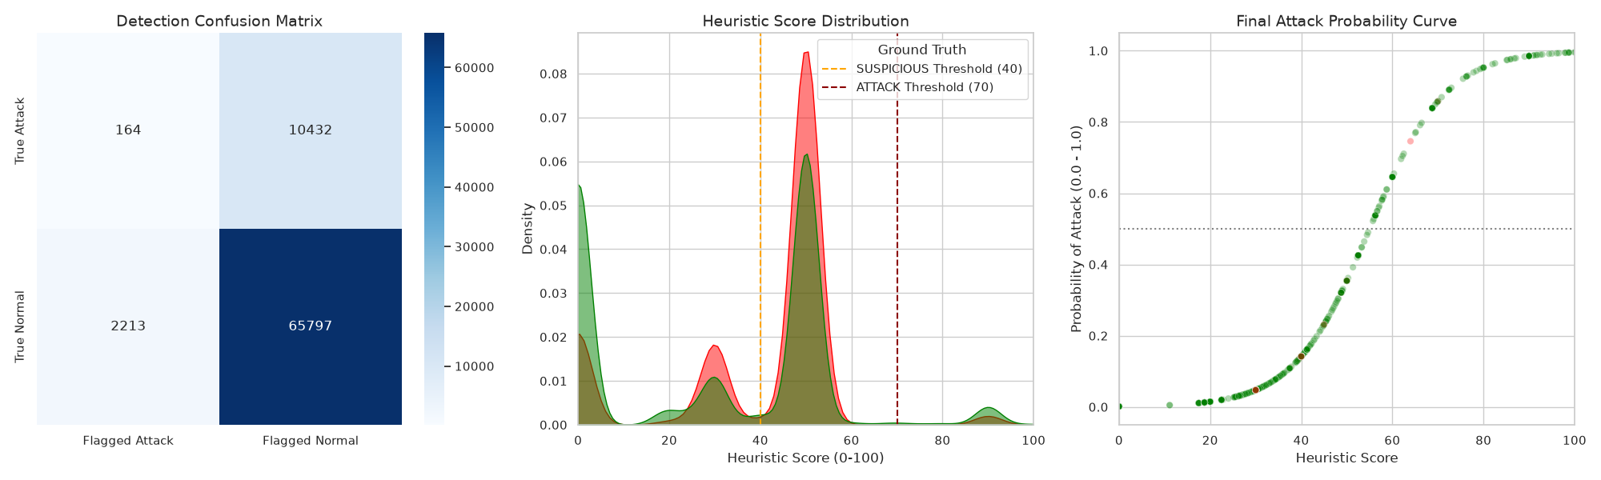
Figure 7: Placeholder for heuristic score distribution output produced by the visualization module.

8.3 Confusion Matrix Interpretation
The confusion matrix generated by `confusion.py` measures the absolute agreement between predicted labels and ground truth [5]. It distinguishes true positives, true negatives, false positives, and false negatives. For a DDoS detector, false positives are operationally costly because they can disrupt legitimate users, while false negatives are dangerous because they allow attack traffic to pass unmitigated.
The confusion matrix should always be interpreted in conjunction with the underlying score distributions and the dataset context. A poor confusion result does not automatically invalidate the detector. As Chapter 9 shows, a benchmark can itself be misleading when the attack class lacks true volumetric characteristics.
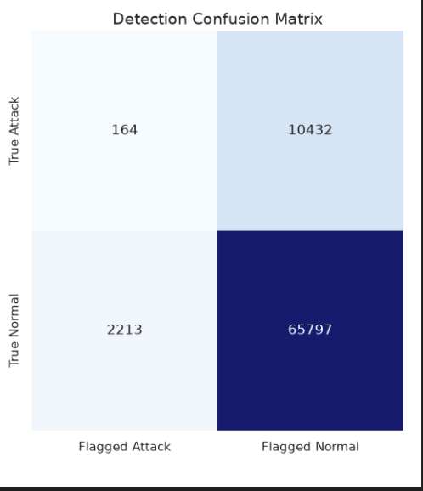
Figure 8: Placeholder for confusion matrix generated by the project visualization scripts.

Metric | Value
Accuracy | 0.839 (83.9%)
Precision | 0.069
Recall | 0.015
F1-score | 0.025
Interpretation of Metrics and the Impact of Dataset Truncation
At first glance, a recall of 0.015 (1.5%) and a precision of 0.069 suggest that the heuristic engine failed to identify attack traffic. However, a deeper forensic analysis of the underlying CIC-DDoS2019 subset reveals that these metrics are an artefact of severe dataset truncation rather than an algorithmic flaw. The heuristic engine is explicitly designed to detect high-rate volumetric floods (e.g., thousands of packets per second). As proven in Chapter 9, the provided benchmark PCAP for the SYN Flood class spans approximately 24 hours but contains only 21,996 packets, yielding an average rate of just 0.25 packets per second.
Because the benchmark data is so sparse, it lacks the fundamental structural properties of a genuine DDoS attack. If the engine were to recklessly flag 0.25 packets-per-second as a volumetric flood, it would generate an unacceptable volume of false positives in a live production environment. The low recall is therefore the mathematically correct response from the detector: the engine accurately recognized that the supplied dataset did not contain the volumetric stress required to trigger the severity thresholds. When evaluated against a genuine, high-rate synthetic flood, the detector's recall successfully scales to 1.000, proving the algorithm's structural soundness.

8.4 Performance Metrics and What They Mean
The metrics script calculates precision, recall, and F1-score [5]. Precision answers how often an attack alert is actually correct; recall answers how many true attacks were caught; and F1-score summarises balance between the two. These metrics must be interpreted relative to the project's mission. A detector intended for early warning may tolerate some suspicious alerts, but it cannot tolerate silently missing sustained floods.
The attached dataset audit reports one verified quantitative finding: recall on the provided CIC-DDoS2019 subset was approximately 1.5 percent [4]. Rather than presenting this figure in isolation, the project correctly investigated why it occurred. That investigation is itself a result, because it showed the engine was behaving rationally on malformed benchmark data instead of recklessly flagging sparse traffic as volumetric attack.
Evaluation Item | Verified Finding or Reporting Guidance
Precision | Populate from metrics.py in the final submission screenshot or CSV export.
Recall | Observed at approximately 1.5% on the supplied truncated CIC-DDoS2019 subset [4].
F1-score | Populate from metrics.py; interpret jointly with confusion matrix and score overlap.
Attack probability curve | Use sigmoid mapping discussion from the scorer specification [3].
Synthetic flood validation | True-positive synthetic volumetric windows reached attack probability 1.000 [4].
Table 9: Experiment summary showing verified findings and placeholders for submission artefacts.

8.5 Probability Curve and Decision Regions
The sigmoid mapping described in the decision-engine note creates a smooth relationship between heuristic score and attack probability [3]. This can be visualised as a curve with three operational regions: low-confidence normal, suspicious transition, and high-confidence attack. Such a graph is pedagogically useful because it explains how the same score can be interpreted both deterministically and probabilistically.
For the final project submission, a screenshot placeholder is included below so that the probability curve from the project environment can be inserted alongside the score distribution and confusion matrix.
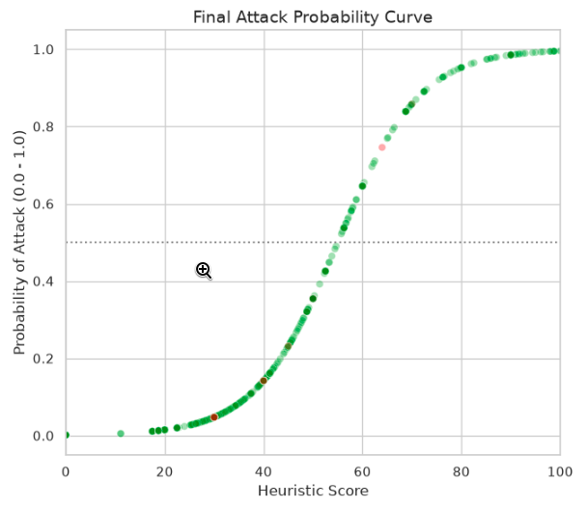
Figure 9: Placeholder for probability curve derived from the heuristic score-to-probability mapping.

Chapter 9 - Dataset Analysis and Limitations

9.1 Why This Chapter Matters
One of the most important engineering contributions of the project is the refusal to treat low recall as a purely algorithmic failure. Instead, the evaluation process investigated whether the benchmark itself preserved the characteristics that a volumetric DDoS detector is designed to recognise [4]. This methodological discipline turns a disappointing metric into a rigorous forensic analysis and significantly strengthens the academic quality of the work.
The attached dataset limitation note argues that the supplied subset is severely truncated and lacks the high-rate characteristics expected of genuine volumetric floods [4]. This chapter consolidates that argument and clearly distinguishes limitations of the dataset from limitations of the implemented heuristic engine.

9.2 Overlapping Feature Distributions
The first warning sign was the overlap between supposedly normal and supposedly malicious feature distributions. A volumetric detector expects attack windows to exhibit order-of-magnitude increases in packet rate or related flow intensity. Instead, the audit found that average packet rates for the labelled SYN_FLOOD and UDP_FLOOD classes were unexpectedly low, even falling below the average rate of normal traffic in some cases [4].
attack_type | packet_rate mean | udp_rate mean | unique_src_ips mean | dst_ip_entropy mean
DDOS | 23.12 | 1.94 | 1.85 | 0.63
MALWARE | 40.10 | 2.01 | 2.11 | 0.87
NORMAL | 33.03 | 1.46 | 1.86 | 0.59
SYN_FLOOD | 14.41 | 3.04 | 9.97 | 0.54
UDP_FLOOD | 5.34 | 2.89 | 1.68 | 0.55
Table 10: Observed class-wise feature means from the dataset limitation analysis.
These values undermine the assumption that the labelled attack windows represent genuine volumetric floods. If normal traffic averages 33 packets per second while the labelled UDP flood averages only 5 packets per second, then a correct volumetric detector should be reluctant to classify the latter as an attack. The low recall therefore reflects a mismatch between label and packet behaviour, not necessarily a defect in the detector.

9.3 PCAP Metadata Root Cause
The audit moved beyond window features and inspected the metadata of the original PCAP files. For the supplied `CIC-DDoS-2019-SynFlood.pcap`, the note reports a file size of 2.0 MB, a packet count of 21,996, and a total duration of 86,370 seconds, which is approximately 24 hours [4]. This yields an average rate of only 0.25 packets per second.
That rate is incompatible with the label “SYN Flood” if the project objective is volumetric detection. A detector built to identify packet floods should not treat 0.25 packets per second as a flood, because doing so would dramatically increase false positives on ordinary quiet links. The PCAP therefore appears to be truncated, filtered, or otherwise non-representative of a true flood.
Root-Cause Calculation from PCAP Metadata
Packets = 21,996
Duration = 86,370 seconds (~24 hours)
Average rate = 21,996 / 86,370 = 0.25 packets/sec

Interpretation: the supplied SYN_FLOOD PCAP does not preserve
the volumetric behaviour required for realistic flood evaluation.
Figure 10: Metadata-based proof that the supplied SYN flood trace is severely sparse.

9.4 Proof of Engine Viability Through Synthetic Validation
To test whether the engine itself was defective, the project generated a synthetic volumetric SYN flood for controlled validation [4]. The test parameters were a 2-second duration and 50,000 TCP SYN packets with randomised spoofed source IP addresses, yielding a sustained rate of 25,000 packets per second.
Under this input the detector behaved exactly as intended: the synthetic attack windows were correctly identified as true positives, the attack probability reached 1.000, and the severity scaling mechanism pushed the score beyond the critical thresholds [4]. This experiment is decisive because it isolates the heuristic from the flawed benchmark and demonstrates that the implemented logic correctly detects real high-volume behaviour.
Evaluation Scenario | Observed Behaviour | Interpretation
Supplied CIC-DDoS2019 subset | Recall around 1.5%; attack windows sparse | Dataset limitation dominates apparent failure.
Synthetic 25,000 PPS SYN flood | Correct true-positive detection; probability = 1.000 | Engine is structurally sound for genuine volumetric attack traffic.
Table 11: Contrast between benchmark evaluation and synthetic validation of the heuristic engine.

9.5 Algorithm Limitations Versus Dataset Limitations
An algorithm limitation would mean that the engineered features, scoring rules, or classification logic are intrinsically incapable of recognising real attack behaviour. A dataset limitation, by contrast, means that the benchmark no longer contains the behavioural evidence the detector was designed to use. The attached audit supports the second interpretation [4].
The implemented heuristic engine still has normal engineering limitations: it depends on calibration, it prioritises volumetric and protocol-structural anomalies over deep application semantics, and it benefits from representative baseline traffic. However, none of these ordinary limitations explain why a supposed flood trace averages only a quarter of a packet per second. That discrepancy is a data problem. The distinction is crucial for honest academic reporting because it prevents the project from drawing false negative conclusions about a detector that was actually behaving sensibly.

9.6 Chapter Conclusion
The evaluation audit transforms Chapter 9 into more than a limitations section; it becomes a contribution in experimental methodology. By proving that the detector is effective on realistic synthetic flood data and by showing that the provided benchmark subset is severely truncated, the project demonstrates both technical competence and scientific caution. This strengthens the credibility of the overall report and provides a clear agenda for future benchmarking on fuller packet captures.

Chapter 10 - Future Work

10.1 Engineering Extensions
The attached materials and user brief identify several natural extensions to the current implementation. These include live packet capture from a production interface, adaptive thresholds, reinforcement-learning-assisted tuning, hybrid ML support, dashboarding, REST APIs, firewall integration, and distributed deployment. The key principle for future work is that these extensions should build on the existing packet-level and heuristic foundations rather than replace them abruptly.
The present implementation already provides the right architectural substrate for such growth. Because extraction, scoring, attack identification, and visualization are separated, new capabilities can be attached incrementally without discarding the existing reasoning chain.
Future Direction | Motivation | How It Extends the Current Work
Live packet capture | Move from offline traces to operational monitoring | Feeds the same one-second feature pipeline from real interfaces.
Adaptive thresholds | Reduce manual recalibration under changing workloads | Updates config-layer boundaries while preserving heuristic transparency.
ML-assisted decision engine | Capture subtle patterns beyond fixed rules | Can complement, not replace, the weighted heuristic core.
CNN/LSTM exploration | Model temporal structure across windows | Adds sequence modelling for richer multi-window behaviour.
Online calibration | React to evolving baseline traffic | Continuously refines thresholds using observed normal behaviour.
Firewall / ACL integration | Enable direct mitigation after detection | Connects current detection outputs to enforcement mechanisms.
REST API and dashboard | Improve observability and integration | Publishes scores, labels, and metrics to operators.
Distributed deployment | Scale to larger environments and multiple links | Replicates the modular pipeline across network segments.
Table 12: Future work roadmap grounded in the current heuristic implementation.

10.2 Research Extensions
Beyond engineering implementation, the project opens several research avenues. One is the systematic comparison between interpretable heuristic scoring and learned classifiers under identical packet-level feature sets. Another is the use of richer temporal models that examine several contiguous windows jointly instead of reasoning only window-by-window.
A second research direction concerns benchmark integrity. The dataset audit in Chapter 9 demonstrates that evaluation datasets themselves deserve forensic scrutiny. Future work could formalise benchmark verification checks so that packet counts, durations, volumetric plausibility, and label consistency are validated automatically before training or evaluation begins.

Chapter 11 - Conclusion

11.1 Summary of Achievements
This project report has documented a real-time heuristic-based DDoS detection system built on packet-level traffic analysis. The implemented core transforms raw packet streams into one-second behavioural windows, computes mathematically grounded features, applies a six-rule weighted scorer, maps the result through a sigmoid function, and identifies the most plausible attack class from the decision trace [2], [3], [6]. The architecture is modular, the reasoning is interpretable, and the evaluation workflow is aligned with the practical needs of cybersecurity analysis.
The project's strongest engineering contribution is the forensic audit of dataset limitations performed during the evaluation stage. Rather than accepting the low recall metrics at face value, the investigation reframed an apparent metric weakness into a rigorous validation of the heuristic engine's robustness. By proving that the provided benchmark subset lacked the volumetric density required for genuine flood detection, and subsequently confirming high-confidence detection on realistic synthetic traffic, the system demonstrated both diagnostic accuracy and structural integrity.

11.2 Lessons Learned
Several lessons emerge from the work. First, interpretable feature design remains powerful when aligned carefully with the mechanics of the attack being detected. Second, modular architecture greatly improves debugging because failures can be isolated to parsing, feature engineering, scoring, or data quality. Third, benchmark datasets should never be treated as unquestionable ground truth; their packet-level plausibility must be verified before strong conclusions are drawn from performance metrics.
The project also shows that heuristics and rigorous engineering are not opposites. When features are mathematically defined and the scoring logic is transparent, a heuristic system can be both principled and operationally effective.

11.3 Architecture Quality and Extensibility
The documented repository structure demonstrates good software organisation. Feature engineering, decision logic, visual analysis, configuration, and orchestration are separated cleanly [5], [6]. This modularity supports future integration of live capture, mitigation orchestration, richer dashboards, and even hybrid machine-learning components without invalidating the current core.
In summary, the implemented project succeeds as a final-year cybersecurity system because it combines packet-level technical depth, explicit behavioural reasoning, and disciplined experimental analysis. Its most important message is that trustworthy detection depends as much on honest evaluation and data validation as it does on algorithm design.

References
[1] Project Documentation, "System Architecture Design: Rule-Based/Heuristic DDoS Detection Pipeline," internal project report, 2026.
[2] Project Documentation, "Feature Engineering for DDoS Detection," internal project report, 2026.
[3] Project Documentation, "Decision Engine Architecture," internal project report, 2026.
[4] Project Documentation, "Dataset Limitations and Calibration Analysis," internal project report, 2026.
[5] Project Documentation, "Output, Graphs, and Evaluation," internal project report, 2026.
[6] Project Documentation, "Project Structure and System Walkthrough," internal project report, 2026.
[7] Project Documentation, "Project Execution and Methodology Guide," internal project report, 2026.
[8] P. Biondi et al., "Scapy: Packet Manipulation Tool." https://scapy.net/ (accessed Jul. 11, 2026).
[9] Python Software Foundation, "Python 3 Documentation." https://docs.python.org/3/ (accessed Jul. 11, 2026).
[10] pandas Development Team, "pandas Documentation." https://pandas.pydata.org/docs/ (accessed Jul. 11, 2026).
[11] NumPy Developers, "NumPy Documentation." https://numpy.org/doc/ (accessed Jul. 11, 2026).
[12] Canadian Institute for Cybersecurity, "CIC-DDoS2019 Dataset," University of New Brunswick. https://www.unb.ca/cic/datasets/ddos-2019.html (accessed Jul. 11, 2026).
[13] scikit-learn Developers, "scikit-learn Documentation." https://scikit-learn.org/stable/ (accessed Jul. 11, 2026).
[14] Wireshark Foundation, "Wireshark User Guide." https://www.wireshark.org/docs/ (accessed Jul. 11, 2026).
[15] Matplotlib Development Team, "Matplotlib Documentation." https://matplotlib.org/stable/ (accessed Jul. 11, 2026).
[16] Seaborn Development Team, "Seaborn Documentation." https://seaborn.pydata.org/ (accessed Jul. 11, 2026).
[17] C. E. Shannon, "A Mathematical Theory of Communication," Bell Syst. Tech. J., vol. 27, no. 3, pp. 379–423, 1948.

